VISVESVARAYA TECHNOLOGICAL UNIVERSITY

“Jnana Sangama”, Machhe, Belagavi, Karnataka-590018

Lab Experiment Record
Project Management with Git [BCSL358C]
Submitted in partial fulfillment towards AEC of 3rd semester of

Bachelor of Engineering

in
Computer Science and Engineering
(Artificial Intelligence & Machine Learning)

Submitted by
SHARANYA S PRASAD
4GW24CI043


DEPARTMENT OF CSE (Artificial Intelligence & Machine Learning)
GSSS INSTITUTE OF ENGINEERING & TECHNOLOGY FOR WOMEN

(Affiliated to VTU, Belagavi, Approved by AICTE, New Delhi & Govt. of Karnataka)
K.R.S ROAD, METAGALLI, MYSURU-570016, KARNATAKA

(Accredited by NAAC)

2025-2026

TABLE OF CONTENTS
Sl.no. | Experiments | Page No.
1 | Setting up and basic commands  Commands initialize a new Git repository in a directory. Create a new fila and add it to the staging area and commit the change with an appropriate commit message | 2 - 4
2 | Creating and managing branches  Create a new branch named "feature-branch". Switch to "master". Merge "feature-branch". | 5 – 6
3 | Stashing Changes and Switching Branches  Stash changes, switch branches, and apply the stashed changes. | 7 – 9
4 | Collaboration and Remote Repositories  Clone a remote Git repository. | 10
5 | Collaboration and Remote Repositories  Fetch latest changes and rebase. | 11 – 12
6 | Collaboration and Remote Repositories  Merge "feature-branch" into "master" with message. | 13
7 | Git Tags and Releases  Create a lightweight Git tag v1.0. | 14
8 | Advanced Git Operations  Cherry-pick a range of commits. | 15 – 16
9 | Analysing and Changing Git History  View commit details by commit ID. | 17
10 | Analysing and Changing Git History  List commits by JohnDoe between dates. | 18
11 | Analysing and Changing Git History  Display last five commits. | 19
12 | Analyzing and Changing Git History  Write the command to undo the changes introduced by the commit with the ID “abc123” | 20

Appendix : https://github.com/sharanyamys1-cloud/4GW24CI043.git

Program 1: Setting Up and Basic Commands
Step 1:
Create a new folder in the system and open Git Bash inside that folder.
Step 2:
Initialize the folder as a Git repository using the git init command.
Step 3:
Configure the user details by setting the email ID and username. This helps Git identify the user for every commit.
Step 4:
Create an empty file named README.md using the appropriate command.
Step 5:
Add some text content to the file so that it can be tracked by Git.
Step 6:
Check the current status of the repository using the status command to view tracked and untracked files.
Step 7:
Add the created file to the staging area. The dot (.) is used to include all files present in the folder.
Step 8:
Save the staged changes into the repository by committing them with a suitable commit message.
Step 9:
Verify the commit by viewing the commit history in a single-line format.
Step 10:
Display the contents of the file to confirm that the changes have been successfully saved.

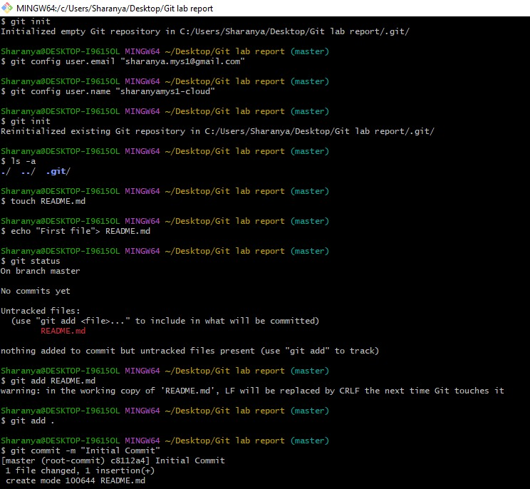

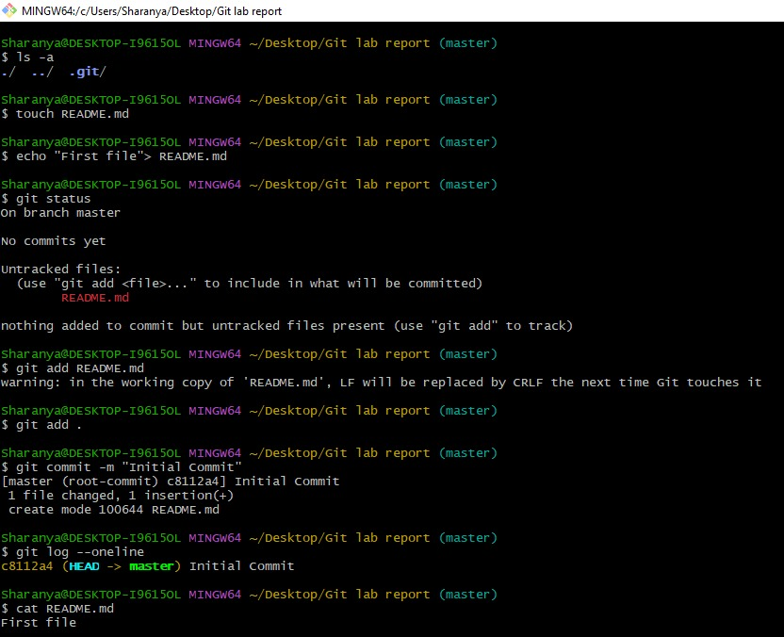

Program 2: Creating and Managing Branches
Step 1:
Create a new folder and open Git Bash inside that folder.
Step 2:
Initialize the folder as a Git repository so that version control can be used.
Step 3:
Create a file in the main (master) branch and add some content to it.
Step 4:
Check the repository status to see the newly created file.
Step 5:
Add the file to the staging area and commit it to the repository with a proper message.
Step 6:
Create a new branch named feature-branch using the branch command.
Step 7:
Verify that the new branch is created by listing all available branches.
Step 8:
Switch from the master branch to the feature-branch.
Step 9:
In the feature branch, create another file or modify an existing file.
Step 10:
Add and commit the changes made in the feature branch.
Step 11:
Switch back to the master branch after completing the work in the feature branch.
Step 12:
Merge the feature-branch into the master branch using the merge command.
Step 13:
Check the repository to confirm that the changes from both branches are now combined in the master branch.
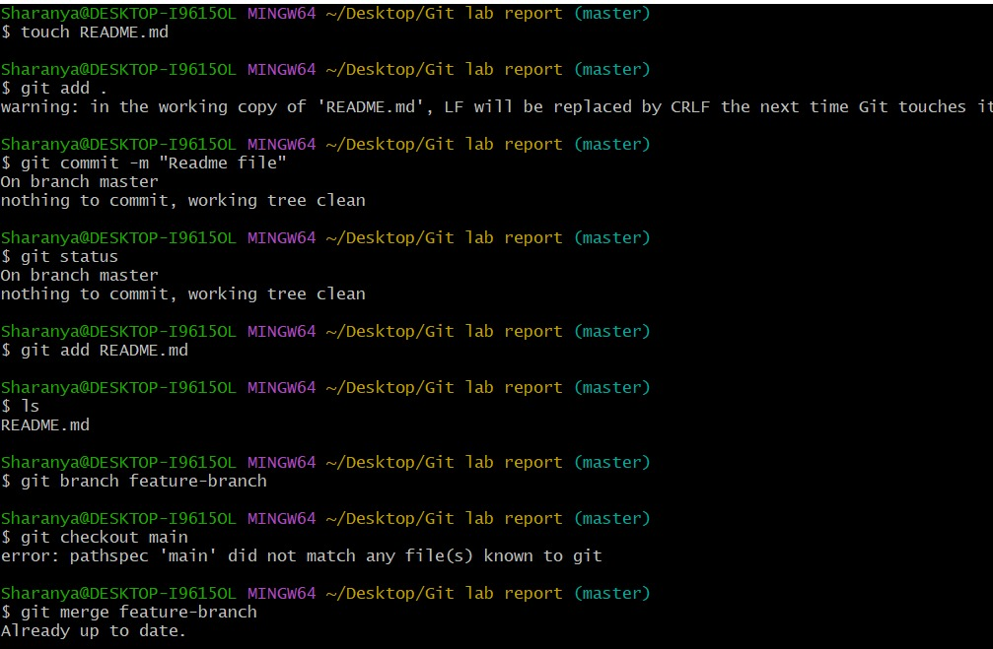

Program 3: Stashing Changes and Switching Branches
Step 1:
Create or open a Git repository and make sure it is already initialized.
Step 2:
Create a new file in the current branch and add some content to the file.
Step 3:
Check the status of the repository to confirm that the file has been modified but not yet committed.
Step 4:
Instead of committing the changes, temporarily save the uncommitted work using the stash command. This stores the changes safely and keeps the working directory clean.
Step 5:
Provide a message while stashing the changes to identify the work easily (WIP indicates work in progress).
Step 6:
After stashing the changes, create a new branch named target-branch and switch to it.
Step 7:
Once switched to the new branch, apply the previously stashed changes to this branch using the stash pop command.
Step 8:
Check the repository status to verify that the stashed changes are now restored in the new branch.
Step 9:
Confirm that the restored file is available and ready to be added or committed in the target branch.

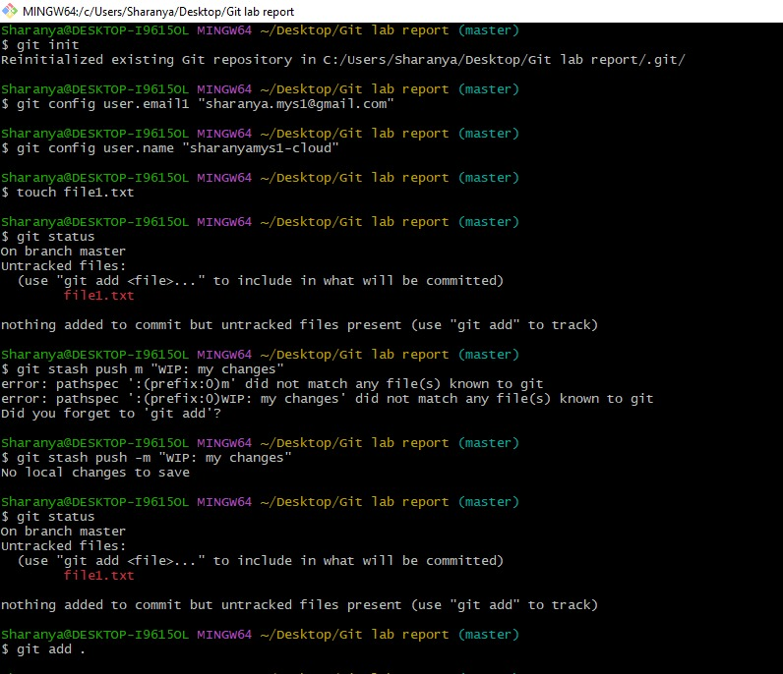
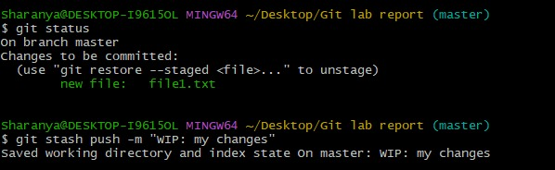
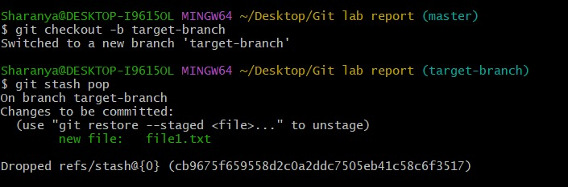
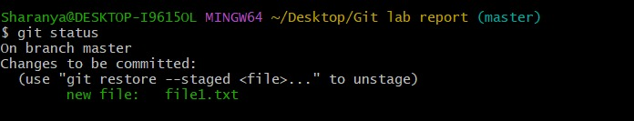

Program 4: Collaboration and Remote Repositories – Cloning a Repository
Step 1:
Create a repository on GitHub using your USN or project name.
Step 2:
Open the created repository on GitHub and click on the Code button.
Step 3:
From the available options, copy the repository URL under the HTTPS section.
Step 4:
Open Git Bash or the terminal on your local system and navigate to the directory where you want to store the project.
Step 5:
Use the clone command along with the copied URL to download the remote repository to the local machine.
Step 6:
After the cloning process is completed, move into the cloned repository directory using the change directory command.
Step 7:
Verify that the repository files are successfully copied by listing the contents of the folder.
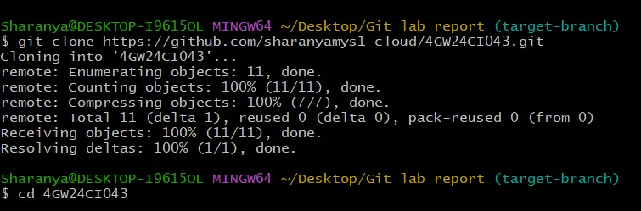

Program 5: Collaboration and Remote Repositories – Fetch and Rebase
Step 1:
Open the cloned Git repository on the local system using Git Bash.
Step 2:
Ensure that the repository is connected to the remote repository (origin).
Step 3:
Fetch the latest updates from the remote main branch without merging them into the local branch.
Step 4:
Create a new branch named target-branch and switch to it for further work.
Step 5:
In the target branch, create a new file or make changes as required.
Step 6:
Rebase the local target-branch onto the updated origin/main branch so that the latest remote changes are applied.
Step 7:
After rebasing, check the repository to ensure that the remote updates and local changes are properly arranged.
Step 8:
List all the files in the directory to confirm that both the fetched remote files and the locally created files are present.
Step 9:
Verify that the changes fetched from the remote repository are reflected locally, even if they are not yet pushed back to GitHub.

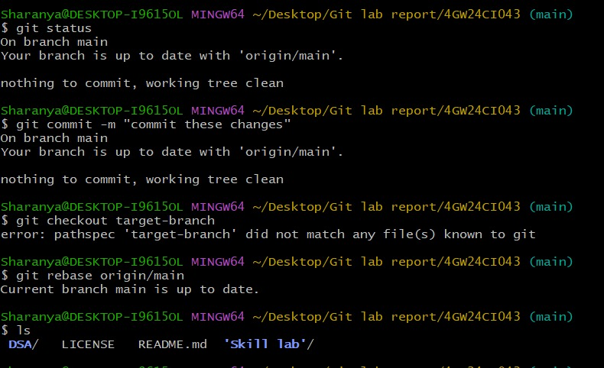

Program 6: Collaboration and Remote Repositories – Merge with Custom Message
Step 1:
Open the Git repository and ensure that both the master branch and feature-branch already exist.
Step 2:
Switch to the master branch, as merging should always be done from the target branch.
Step 3:
Confirm that the current branch is master before performing the merge operation.
Step 4:
Use the merge command along with the -m option to provide a meaningful custom commit message.
Step 5:
Merge the feature-branch into the master branch. This combines the changes from the feature branch into the main branch.
Step 6:
After merging, Git creates a new merge commit that preserves the history of both branches.
Step 7:
Verify that the merge is successful by checking the commit history or repository status.

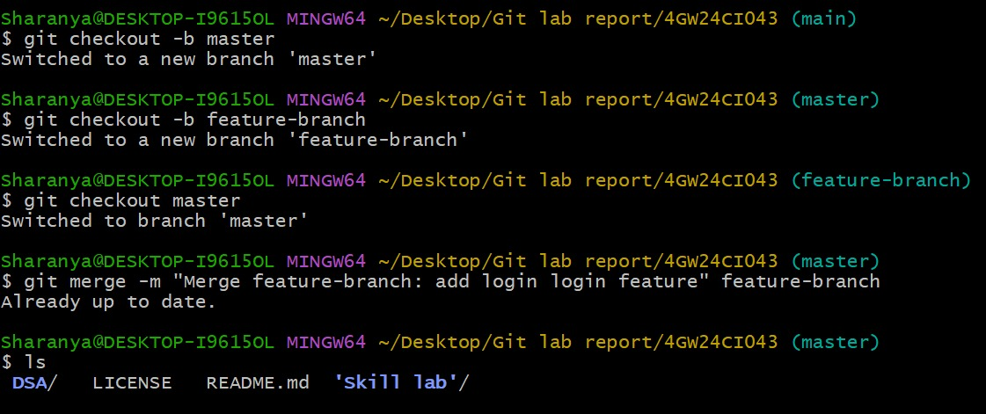

Program 7: Git Tags and Releases – Creating a Lightweight Tag
Step 1:
Open the local Git repository that already contains one or more commits.
Step 2:
Ensure that the repository is in a clean state and that the required commit is available.
Step 3:
Create a lightweight tag named v1.0 for the current commit. This tag acts as a reference point to mark an important version of the project.
Step 4:
Understand that a lightweight tag does not store additional information such as author or message. It simply points to a specific commit.
Step 5:
Use the log command to view the commit history and confirm that the tag v1.0 is attached to the commit.
Step 6:
Verify that the tag is successfully created and can be used later for version identification.

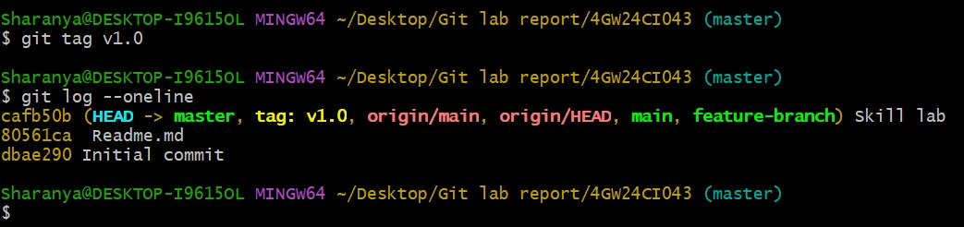

Program 8: Advanced Git Operations – Cherry-pick a Range of Commits
Step 1:
Create a branch (source-branch) and make commits. Add files and commit changes to record updates.
Step 2:
Switch to the target branch (master) where you want to apply the commits.
git checkout master
Step 3:
View recent commits in the source branch to identify the range to pick.
git log source-branch --oneline
Step 4:
Apply a range of commits from source-branch using cherry-pick.
git cherry-pick <oldest-commit>^..<newest-commit>
Step 5:
Abort the cherry-pick if required, which restores the branch to the previous state.
git cherry-pick --abort

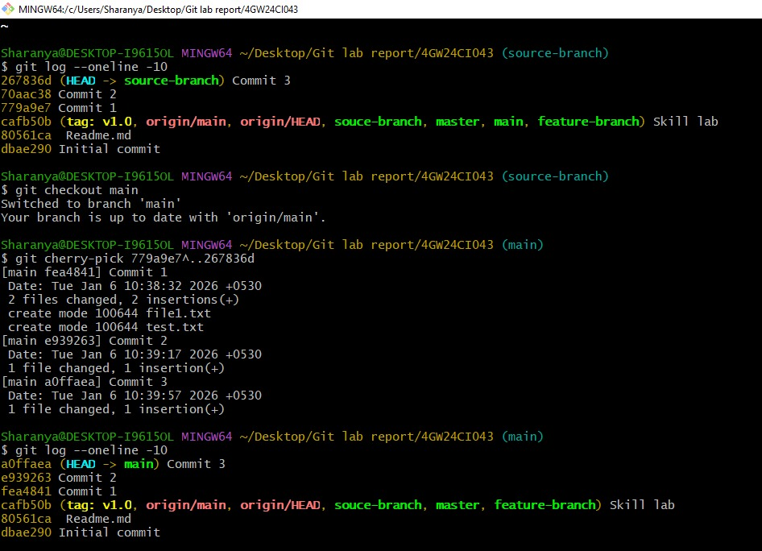

Program 9: Analysing and Changing Git History – View Commit Details
Step 1:
Identify the commit ID you want to inspect. Use git log if needed:
git log --oneline
Step 2:
View full details of the commit including author, date, message, and file changes.
git show <commit-id>
Step 3 :
View only the commit message or summary of files changed:
git show --no-patch <commit-id>
git show --stat <commit-id>
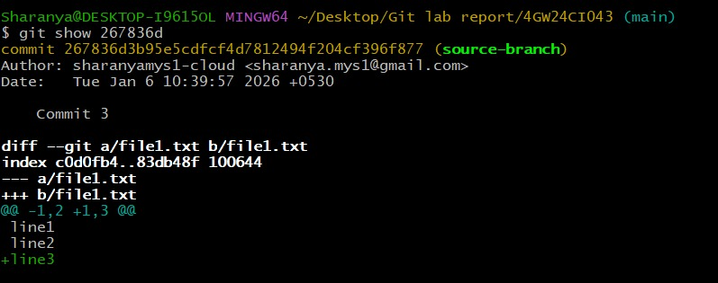

Program 10: Analysing and Changing Git History – List Commits by Author in a Date Range
Step 1:
Open the local Git repository where the commits are made.
Step 2:
Identify the author whose commits you want to list (e.g., "JohnDoe").
Step 3:
Specify the date range for the commits you want to see (e.g., from "2023-01-01" to "2023-12-31").
Step 4:
Use the git log command with --author, --since, and --until options:
git log --author="JohnDoe" --since="2023-01-01" --until="2023-12-31"
Step 5:
Review the output, which lists all commits by the author within the specified date range.
Step 6 :
Adjust the author name or date range as needed to filter different commits.
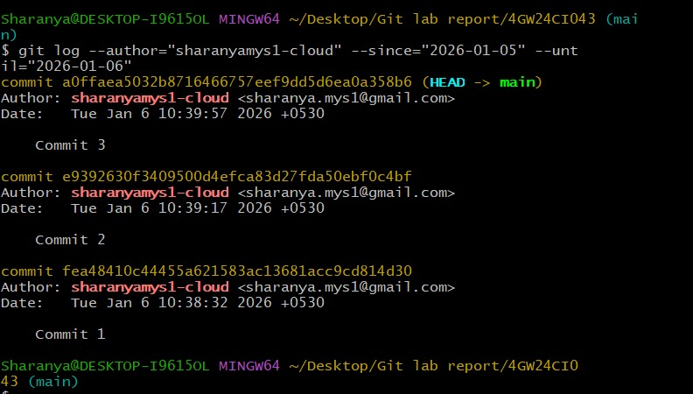

Program 11: Analysing and Changing Git History – Display Last 5 Commits
Step 1:
Open the local Git repository where you want to check the commit history.
Step 2:
Decide how many recent commits you want to display (e.g., 5).
Step 3:
Use the git log command with the -n option to limit the number of commits:
git log -n 5
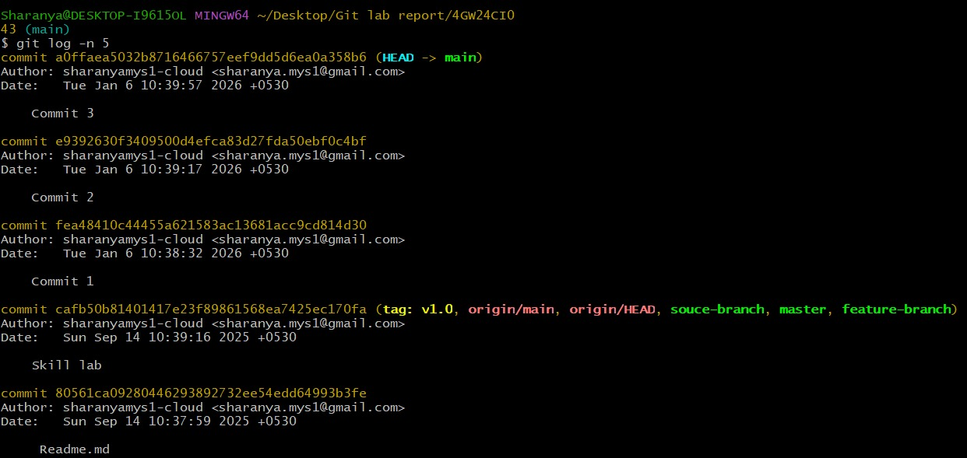
Step 4:
Review the output, which shows the last five commits in the repository.

Program 12: Analyzing and Changing Git History – Undo Changes from a Specific Commit
Step 1:
Open the local Git repository where the commit exists.
Step 2:
Identify the commit ID you want to undo (e.g., "abc123").
Step 3:
Use the git revert command to create a new commit that undoes the changes:
git revert <commit-id>
Step 4:
Git will open the commit message editor. You can keep the default message or edit it, then save and close to complete the revert.
Step 5:
The repository now has a new commit that negates the changes of the specified commit, preserving history safely.
Step 6 :
Replace <commit-id> with any other commit ID to revert different commits as needed.
